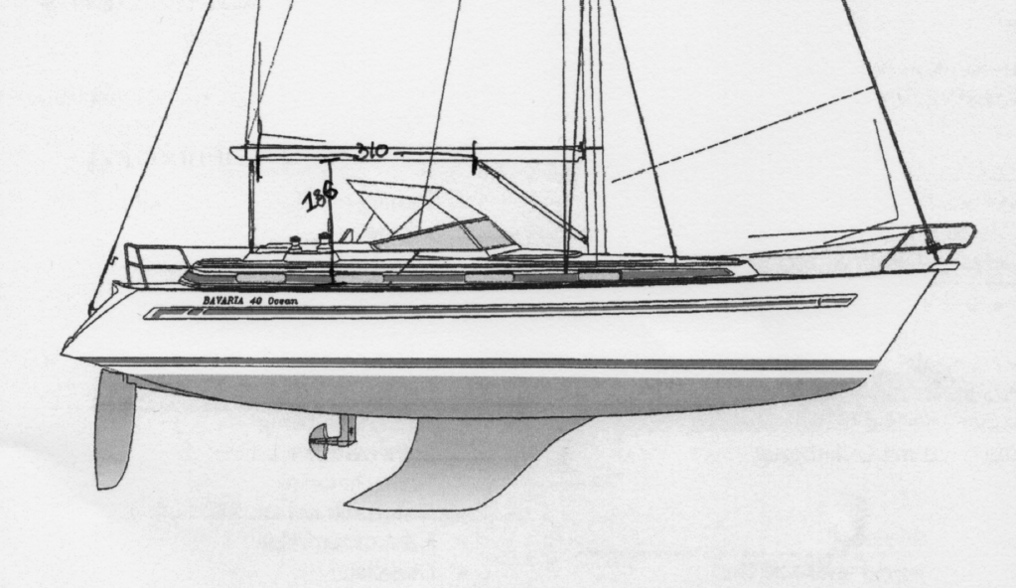

Dimensions are in cm.
310 cm from Traveller to Kicking strap
186 from deck to boom



